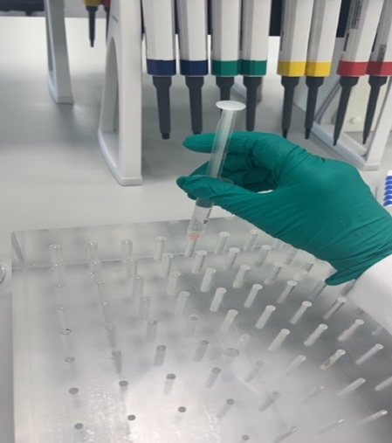

Figure 1. Phantom that will be used in the current research.

The holes within the phantom can be injected with fluid to mimic the CT properties of tissue. For example, iodine contrast media will be prepared at similar concentrations used in the clinical setting to investigate the severity of information loss on fusion PET/CT image. Iodine will be used as it has a high atomic numberleading to high attenuation of Xrays leading to a very clear appearance of the holes within an image. However, water is commonly used as a negative contrast media in CT imaging and so will also be used to fill the phantom holes within the studies to be undertaken.